**SPRING ISSUES**

1. [JSON parse error: Cannot deserialize value of type `java.time.LocalDateTime` from String](https://stackoverflow.com/questions/61202937/json-parse-error-cannot-deserialize-value-of-type-java-time-localdatetime-fro)**.**

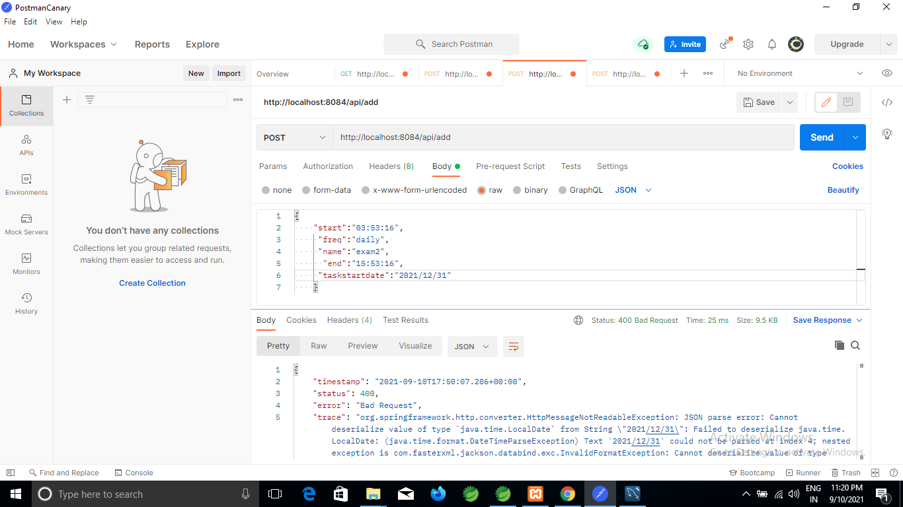

Solution:

